1. Which are the top three variables in your model which contribute most towards the probability of a lead getting converted?

**Lead Source Welingak Website, Lead Source Reference and Current occupation**

**Working Professional are the top three variables contributing towards probability of**

**getting converted.**

**Thus, it is inferred that the Lead Sources – Welingak Website and by Reference**

**and Working Professionals are most likely to get converted into taking a course.**

1. What are the top 3 categorical/dummy variables in the model which should be focused the most on to increase the probability of lead conversion?

**Lead Source Welingak Website, Lead Source Reference and Current occupation**

**Working Professional are the top 3 categorical variables contributing to lead conversion.**

**To increase the lead conversion, the sales team must consider applicants applying via these medium as potential leads comparative to other mediums and consistently follow up with them. In this case, more marketing should be done through the Welingak website and more rewards should be given to referrals to increase the medium. The courses should be targeted at Working Professionals branding hike benefits on up taking the course.**

1. X Education has a period of 2 months every year during which they hire some interns. The sales team, has around 10 interns allotted to them. So during this phase, they wish to make the lead conversion more aggressive. So they want almost all of the potential leads (i.e. the customers who have been predicted as 1 by the model) to be converted and hence, want to make phone calls to as much of such people as possible. Suggest a good strategy they should employ at this stage.

**With the Logistic Regression Results with the existing Model Design, it is observed that 0.35 is the cutoff probability threshold with the perfect intersection of the Accuracy, Sensitivity and Specificity which a lead gets converted to a student. So in order to get maximum results with interns, it is best to consider every single lead with more than 30 as their lead score and follow it up aggressively.**

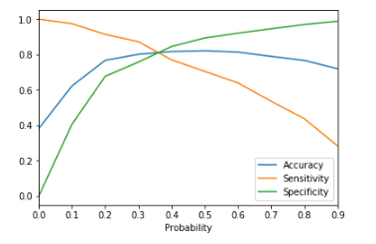

1. Similarly, at times, the company reaches its target for a quarter before the deadline. During this time, the company wants the sales team to focus on some new work as well. So during this time, the company’s aim is to not make phone calls unless it’s extremely necessary, i.e. they want to minimize the rate of useless phone calls. Suggest a strategy they should employ at this stage.

**The greatest advantage of computing lead scores is that one can rank up the most probable potential lead to the least probable potential lead. A simple sorting with the gives the most potential leads to get converted. The sales team should now target from the lead with highest score unto leads with lead score greater than 30.**